Final Project Report Template
1.Introduction
Cardiovascular disease (CVD) is one of the leading health challenges worldwide, and early identification of individuals at higher risk is essential for effective prevention and management. The increasing availability of patient-level healthcare data provides an opportunity to analyze multiple risk factors and understand their relationship with heart disease. However, these factors are often distributed across demographic, clinical, and lifestyle categories, including age, BMI, cholesterol, blood pressure, heart rate, smoking status, family history, exercise, stress, sleep, and chest pain type. Analyzing these factors individually can make it difficult to identify meaningful patterns and high-risk patient groups.
This project proposes an interactive heart disease analytics dashboard that integrates demographic, clinical, and lifestyle data into a single, user-friendly platform. The dashboard enables healthcare stakeholders to explore and compare heart disease patterns across factors such as smoking status, chest pain type, BMI, family history, and age. By providing interactive visualizations and segment-based analysis, the dashboard helps identify groups that may have higher levels of heart disease occurrence and highlights relationships among important risk factors.
The objective of the proposed solution is to transform complex patient data into clear and accessible insights that can support preventive healthcare, early screening, patient counselling, and informed healthcare resource allocation. By bringing multiple risk factors together in one analytical view, the dashboard can help healthcare teams better understand heart disease patterns and make data-informed decisions for prevention and risk management.
1.1. Project overviews
Heart disease is a major health concern that is influenced by a combination of demographic, clinical, and lifestyle factors. Factors such as age, body mass index (BMI), cholesterol level, blood pressure, heart rate, smoking habits, family history, physical activity, stress, sleep patterns, and chest pain type can provide valuable information about an individual's cardiovascular health. Analyzing these factors together can help identify patterns and groups of patients who may have a higher occurrence of heart disease.

The Heart Disease Risk and Patient Health Analysis project focuses on analyzing patient-level healthcare data to understand the relationship between different risk factors and heart disease. The project brings together clinical, demographic, and lifestyle attributes and presents them through an interactive analytical dashboard. Users can explore patterns based on age, gender, smoking status, chest pain type, BMI, family history, and other relevant health indicators.

The dashboard is designed to convert complex healthcare data into meaningful visual insights. It allows healthcare stakeholders to compare patient groups, identify important risk patterns, and examine how multiple factors are associated with heart disease. These insights can support preventive healthcare activities such as early screening, health counselling, lifestyle awareness, and better allocation of healthcare resources. Overall, the project demonstrates how data analytics and interactive visualization can provide a consolidated view of patient health information and support data-informed cardiovascular risk analysis.

1.2. Objectives
The main objective of the Heart Disease Risk and Patient Health Analysis project is to analyze patient health data and identify patterns and relationships between various demographic, clinical, and lifestyle factors and the occurrence of heart disease.

The specific objectives of the project are:

- To analyze patient health data based on factors such as age, BMI, cholesterol, blood pressure, heart rate, smoking status, family history, exercise, stress, sleep, and chest pain type.

- To identify patterns and trends associated with heart disease across different patient groups.

- To examine the relationship between lifestyle factors and heart disease occurrence.

- To compare heart disease patterns across demographic and clinical characteristics.

- To identify patient segments that show higher levels of heart disease occurrence based on the available data.

- To develop an interactive dashboard that presents healthcare data through clear and meaningful visualizations.

- To enable users to filter and explore patient information based on important health and risk factors.

- To provide data-driven insights that can support preventive healthcare, early screening, patient counselling, and healthcare resource planning.

- To demonstrate how data analytics and visualization can help healthcare stakeholders understand complex patient-level information more effectively.

2. Project Initialization and Planning Phase
The Project Initialization and Planning Phase is the first stage of the Heart Disease Risk and Patient Health Analysis project. It establishes the overall direction of the project by defining its purpose, scope, objectives, data requirements, analytical methods, tools, and expected outcomes. Proper planning helps ensure that patient health data is analyzed systematically and presented through an effective and interactive dashboard.

The project focuses on combining demographic, clinical, and lifestyle information to understand patterns related to heart disease. Key attributes such as age, BMI, cholesterol, blood pressure, heart rate, smoking status, family history, exercise, stress, sleep, and chest pain type are considered for analysis. By bringing these factors together, the project aims to provide a comprehensive view of patient health and identify groups with higher levels of heart disease occurrence in the dataset.

During this phase, the project requirements are identified, the available dataset is examined, and appropriate data preparation and visualization techniques are planned. The workflow includes data collection, data cleaning, exploratory analysis, risk-factor analysis, dashboard development, testing, and interpretation of results.

The planned dashboard will provide interactive charts, graphs, filters, and key indicators that allow users to examine heart disease patterns across different patient characteristics. The final output is expected to transform complex patient-level data into clear and understandable insights that can support preventive healthcare, early screening, patient counselling, and informed healthcare resource planning.

2.1 Define Problem Statement

In this milestone, the project begins by clearly defining the problem of analyzing heart disease risk and patient health factors. Heart disease is influenced by multiple demographic, clinical, and lifestyle factors, making it important to examine these attributes together rather than individually. The project aims to identify patterns and relationships between patient characteristics and heart disease occurrence using data-driven analysis.
The key objectives are to understand which factors are associated with heart disease, identify patient groups with higher levels of heart disease occurrence, and determine how factors such as age, BMI, cholesterol, blood pressure, heart rate, smoking status, family history, exercise, stress, sleep, and chest pain type relate to patient health outcomes.
The major business questions considered in this project include:
- How does heart disease occurrence vary across different age groups?
- What relationship can be observed between heart disease and smoking status?
- How does chest pain type vary among patients with and without heart disease?
- What patterns can be observed based on BMI, cholesterol, blood pressure, and heart rate?
- How does family history relate to heart disease occurrence?
- Which patient groups show higher levels of heart disease in the available dataset?
- How can these findings be presented through an interactive dashboard for easier analysis?
To address these questions, a relevant patient health dataset is collected from an appropriate source and examined for its structure and completeness. The dataset is reviewed based on the available records, columns, data types, and key attributes. Data quality is also assessed by checking for missing values, duplicate records, inconsistent values, and other potential issues.
Finally, the collected data is evaluated to determine whether it contains sufficient and relevant information to support the defined objectives. This ensures that the dataset is suitable for further data cleaning, exploratory analysis, visualization, and dashboard development as part of the Heart Disease Risk and Patient Health Analysis project.
2.2. Project Proposal (Proposed Solution)
The proposed solution is to develop an interactive Heart Disease Risk and Patient Health Analysis dashboard that integrates demographic, clinical, and lifestyle information into a single analytical platform. The dashboard will transform patient-level healthcare data into meaningful visual insights, making it easier to identify patterns and relationships associated with heart disease.
The proposed system will analyze important patient attributes such as age, BMI, cholesterol, blood pressure, heart rate, smoking status, family history, exercise, stress, sleep, and chest pain type. Interactive charts, graphs, key performance indicators, and filters will allow users to examine heart disease patterns across different patient groups and health factors.
The solution will follow a structured data analytics process consisting of data collection, data cleaning, data transformation, exploratory analysis, visualization, and dashboard development. Data will be validated and prepared before analysis to improve the reliability and consistency of the results.
The dashboard will provide users with the ability to:
- View an overall summary of patient health and heart disease occurrence.
- Compare heart disease patterns across different age groups and demographic categories.
- Analyze the relationship between smoking status, family history, and heart disease.
- Examine heart disease patterns based on chest pain type, BMI, cholesterol, blood pressure, and heart rate.
- Apply interactive filters to focus on specific patient groups.
- Identify segments with higher levels of heart disease occurrence within the dataset.
- Present complex healthcare information through simple and understandable visualizations.
The expected outcome of the proposed solution is a centralized analytical dashboard that enables healthcare stakeholders to explore patient health data more efficiently. The insights generated from the available dataset can support preventive healthcare planning, early screening analysis, patient counselling, and informed allocation of healthcare resources. The project demonstrates how data analytics and visualization can be used to convert complex patient information into actionable insights for heart disease risk analysis.

2.3. Initial Project Planning
The initial project planning phase defines the activities, resources, tools, and timeline required to successfully develop the Heart Disease Risk and Patient Health Analysis project. The project will follow a structured approach, beginning with understanding the healthcare problem and collecting the required dataset, followed by data preparation, analysis, visualization, dashboard development, and final documentation.
The initial plan is divided into the following major activities:
Phase | Major Activities | Expected Outcome
1. Problem Understanding | Define the problem, objectives, scope, and key business questions | Clearly defined project requirements
2. Data Collection | Identify and collect a relevant patient health dataset | Required healthcare dataset
3. Data Understanding | Examine columns, data types, records, and important attributes | Understanding of dataset structure
4. Data Cleaning | Handle missing values, duplicates, inconsistent and invalid data | Clean and reliable dataset
5. Data Analysis | Perform exploratory analysis and examine relationships between risk factors and heart disease | Identification of important patterns
6. Dashboard Design | Select suitable KPIs, charts, filters, and visual layouts | Dashboard design plan
7. Dashboard Development | Build interactive visualizations and analytical components | Functional interactive dashboard
8. Testing and Validation | Verify calculations, filters, visualizations, and data accuracy | Validated dashboard
9. Insights and Documentation | Interpret findings and document methodology, results, and conclusions | Final project report and insights
Resources and Tools
The project may require the following resources:
  - Dataset: Patient-level heart disease and health-related data.
  - Data Processing: Excel, SQL, or Python for cleaning and transformation.
  - Visualization: Power BI or Tableau for interactive dashboard development.
  - Documentation: Word or similar documentation software for preparing the project report.
  - Hardware: A computer system capable of processing the dataset and running the selected analytical and visualization tools.
Key Deliverables
The planned deliverables of the project include:
  - Cleaned and prepared patient health dataset.
  - Exploratory data analysis and identified patterns.
  - Interactive heart disease analysis dashboard.
  - Visualizations covering demographic, clinical, and lifestyle factors.
  - Summary of important findings and observations.
  - Final project documentation and presentation.
This initial planning provides a clear roadmap for developing the project systematically and ensures that each stage contributes toward the overall goal of creating a comprehensive dashboard for heart disease risk and patient health analysis.

3. Data Collection and Preprocessing Phase
The Data Collection and Preprocessing Phase is an important step in the heart disease risk analysis project. In this phase, the dataset is collected, examined, and prepared for analysis using Power BI. The dataset used for this project is heart_disease_risk_2026.csv, containing 9,000 patient records across 27 attributes, covering demographics, vital signs, cholesterol and blood-sugar measurements, chest pain and exercise-test results, lifestyle habits, and heart disease diagnosis.
3.1. Data Collection Plan and Raw Data Sources Identifie
Data Collection Plan
The primary objective of data collection is to obtain patient health information required to analyze heart disease risk factors and identify patterns in patient health conditions.
The dataset, heart_disease_risk_2026.csv, contains information about 9,000 patients and 27 attributes. These attributes include demographic details, medical measurements, lifestyle habits, and heart disease diagnosis.
The collected data will be used to develop interactive visualizations and dashboards in Power BI. These visualizations help identify relationships between health factors such as age, cholesterol, blood pressure, smoking habits, chest pain, and heart disease.
Raw Data Sources Identified
Data Source | Description
heart_disease_risk_2026.csv | Main dataset used for the project
Patient Demographics | Age, gender, and other demographic attributes
Vital Signs | Blood pressure and heart rate measurements
Medical Measurements | Cholesterol and blood-sugar values
Lifestyle Information | Smoking habits and other lifestyle factors
Clinical Test Results | Chest pain and exercise-test results
Diagnosis Information | Heart disease diagnosis and related outcomes
Data Collection Objective:
To collect structured patient data that can be analyzed to identify risk factors and patterns associated with heart disease.
3.2. Data Quality Report
A data quality report is prepared to examine the accuracy, completeness, consistency, and reliability of the dataset before performing analysis.
The dataset contains 9,000 records and 27 attributes. The quality assessment focuses on identifying missing values, duplicate records, incorrect data types, and inconsistent values.
Data Quality Assessment
Quality Parameter | Description
Dataset Size | 9,000 patient records and 27 attributes
Missing Values | Check for empty or null values
Duplicate Records | Identify and remove duplicate entries, if present
Data Types | Verify numerical and categorical data types
Inconsistent Values | Identify invalid or inconsistent entries
Outliers | Examine unusual medical measurements
Data Completeness | Check whether required attributes are available
Data Quality Checking Process
- Missing Value Check: Identify missing values in patient records and determine how they should be handled.
- Duplicate Record Check: Check for duplicate patient records to avoid repeated information.
- Data Type Validation: Ensure that numerical fields, such as age and cholesterol, are stored correctly.
- Range Validation: Examine values such as blood pressure, heart rate, and cholesterol for potentially invalid entries.
- Consistency Check: Verify that categorical fields, such as smoking status and chest pain type, use consistent labels.
Note: The actual number of missing values, duplicate records, and outliers must be calculated from the CSV file. The dataset size alone does not confirm the results of these checks.
3.3. Data Exploration and Preprocessing
Data exploration and preprocessing involve understanding the dataset and preparing it for visualization and analysis. This step helps improve data quality and ensures that the dataset is suitable for creating meaningful Power BI dashboards.
3.3.1. Data Exploration
Data exploration is performed to understand the structure, characteristics, and distribution of the patient data.
The following activities are carried out:
- Examine the number of rows and columns.
- Identify numerical and categorical attributes.
- Analyze patient age and gender distribution.
- Explore cholesterol, blood pressure, and blood-sugar measurements.
- Examine chest pain types and exercise-test results.
- Analyze smoking groups and heart disease diagnosis.
- Identify patterns and relationships between health factors.
Example Exploration Questions:
- How does heart disease diagnosis vary across different age groups?
- How does chest pain type vary across smoking groups?
- What is the relationship between cholesterol levels and heart disease?
- How do exercise-test results differ between patients with and without heart disease?
- How does heart disease risk vary between male and female patients?

3.3.2. Data Preprocessing
Data preprocessing is the process of cleaning and transforming raw data into a suitable format for analysis.
Preprocessing Steps:
Step | Description
Data Cleaning | Remove invalid and unnecessary data
Missing Value Handling | Identify and manage missing values
Duplicate Removal | Remove duplicate records, if present
Data Transformation | Convert data into appropriate formats
Column Renaming | Use clear and meaningful column names
Data Type Conversion | Assign correct data types to columns
Data Validation | Verify that the cleaned data is suitable for analysis

3.3.3. Data Preparation Using Power BI
The dataset is imported into Power BI using the Get Data → Text/CSV option. Power Query Editor is then used to clean and transform the data.
The following operations are performed:
- Import the heart_disease_risk_2026.csv file into Power BI.
- Review the dataset structure and column names.
- Check for missing values and duplicate records.
- Assign appropriate data types to each column.
- Clean inconsistent categorical values.
- Apply necessary transformations in Power Query.
- Load the cleaned dataset into Power BI for visualization.

3.3.4. Expected Outcome
After completing the data collection and preprocessing phase, the dataset will be prepared for further analysis. The cleaned data will support the creation of interactive dashboards, charts, and reports to study heart disease patterns and risk factors.
Conclusion:
The Data Collection and Preprocessing Phase ensures that patient data is organized, validated, and ready for effective analysis using Power BI.
4. Data Visualization

In this milestone, meaningful and interactive visualizations will be created using Microsoft Power BI to analyze the prepared heart disease dataset and identify important healthcare insights. The visualizations will help understand patient health conditions, identify heart disease risk factors, and explore relationships between medical measurements, lifestyle habits, and heart disease diagnosis.
The project focuses on developing KPIs, business questions, charts, and interactive dashboards that communicate insights clearly and support data-driven healthcare analysis.
4.1. Framing Business Questions
Business questions are framed to identify the key healthcare insights that can be obtained from the dataset. These questions guide the selection of appropriate visualizations, dimensions, and measures in Power BI.
Business Questions
S.No. | Business Question
1 | What is the total number of patients and the number of patients diagnosed with heart disease?
2 | How does heart disease diagnosis vary across different age groups?
3 | How does chest pain type vary across smoking groups?
4 | What is the relationship between cholesterol levels and heart disease diagnosis?
5 | How do exercise-test results vary between patients with and without heart disease?
6 | How does heart disease diagnosis differ between male and female patients?
7 | How do blood pressure levels vary across different patient groups?
8 | What is the distribution of heart disease diagnosis across different lifestyle habits?
9 | How does heart disease diagnosis vary according to blood-sugar levels?
10 | Which patient health factors show patterns associated with heart disease diagnosis?
Business Objectives
- Identify important patterns in patient health data.
- Compare heart disease diagnosis across demographic groups.
- Analyze relationships between lifestyle habits and medical conditions.
- Understand the distribution of clinical test results.
- Create interactive dashboards for healthcare data analysis.

4.2. Developing Visualizations
- In this phase, Power BI visualizations will be developed using the prepared dataset, heart_disease_risk_2026.csv. The charts and KPIs will represent trends, comparisons, distributions, and relationships among patient health attributes.
- The visualizations will be customized using suitable colors, titles, labels, filters, and interactive slicers to improve dashboard readability and user experience.

4.2.1. Key Performance Indicators (KPIs)
- KPIs are used to display important summary information about the dataset.
KPI | Description
Total Patients | Total number of patient records
Heart Disease Cases | Number of patients diagnosed with heart disease
Heart Disease Percentage | Percentage of patients diagnosed with heart disease
Average Age | Average age of the patients
Average Cholesterol | Average cholesterol level
Average Blood Pressure | Average blood pressure measurement, based on the available field
Purpose:
- KPIs provide a quick overview of patient health information and heart disease diagnosis patterns.
- The actual KPI values will be calculated from the dataset in Power BI.

4.2.2. Visualizations Developed
1. Heart Disease Diagnosis by Age Group
Chart: Clustered Column Chart
Purpose: To compare heart disease diagnosis across different age groups and identify variations in patient outcomes.
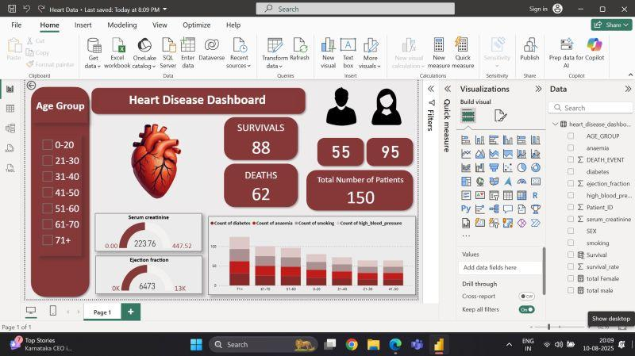

2. Chest Pain Patterns Across Smoking Groups
Chart: Clustered Bar Chart
Purpose: To compare the distribution of chest pain types among current, former, and never smokers.
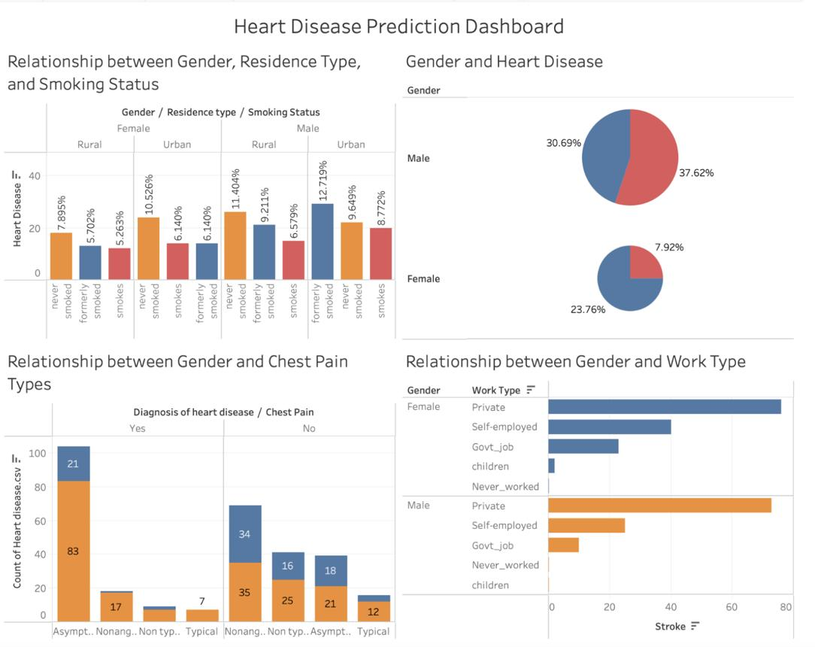

3. Cholesterol Levels and Heart Disease
Chart: Scatter Chart
Purpose: To explore the relationship between cholesterol measurements and heart disease diagnosis.
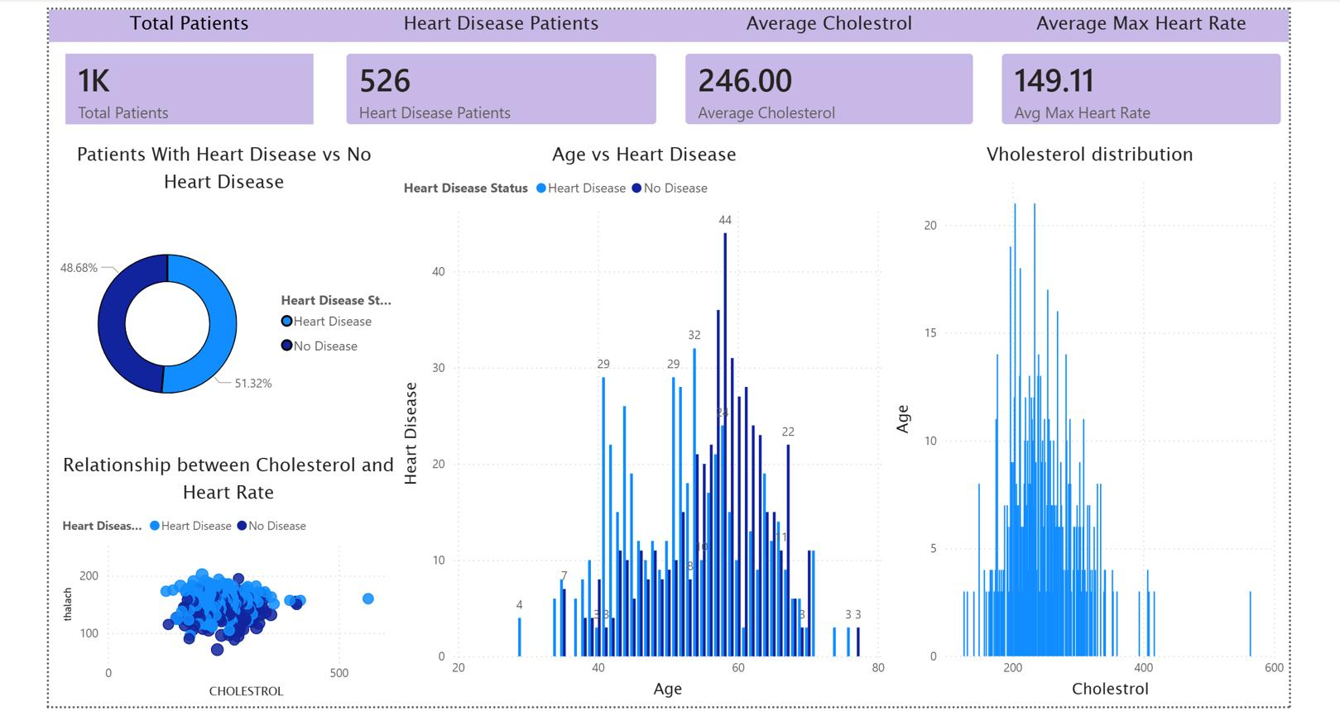

4. Exercise-Test Results and Heart Disease
Chart: Donut Chart or Clustered Column Chart
Purpose: To compare exercise-test results among patients with different heart disease diagnoses.
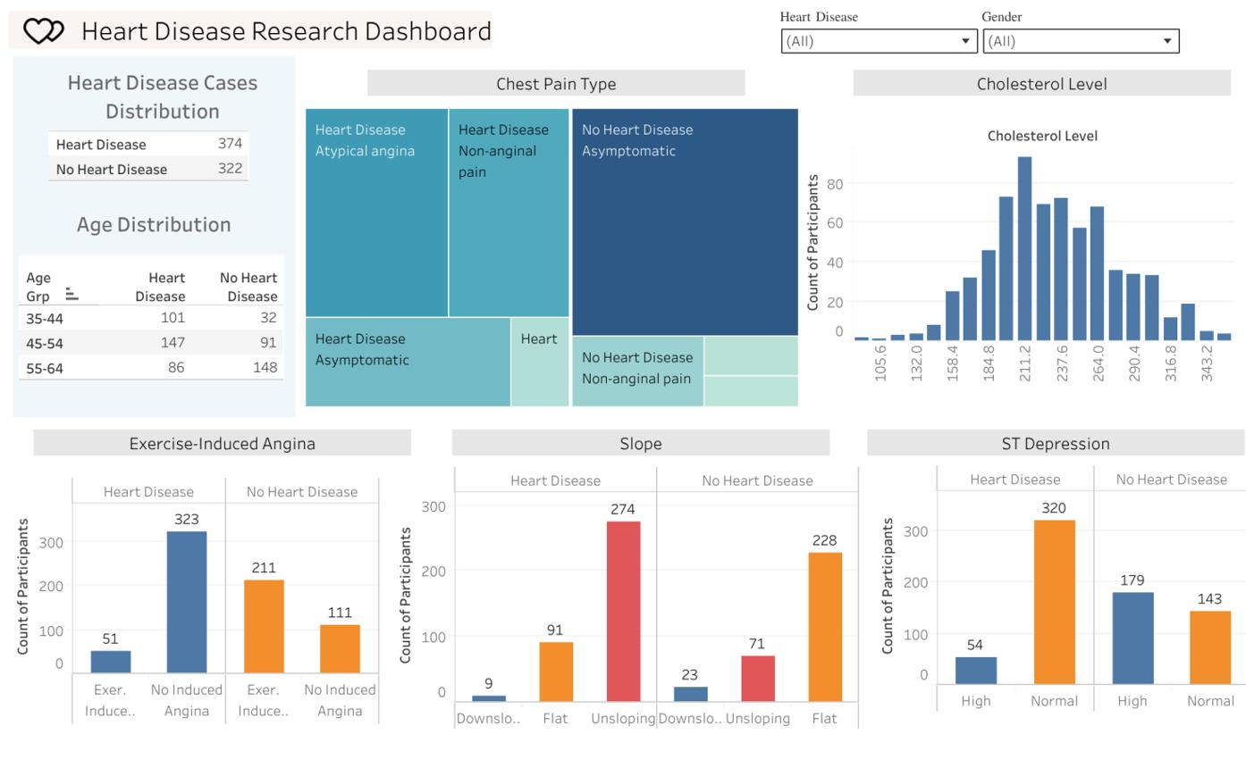

5. Heart Disease Diagnosis by Gender
Chart: Stacked Column Chart
Purpose: To compare heart disease diagnosis across gender categories in the dataset.

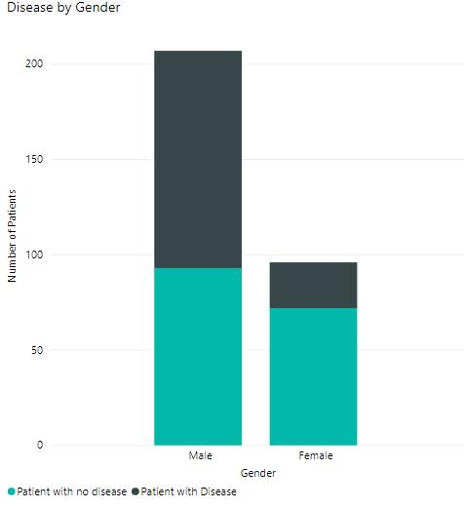

6. Blood Pressure Distribution
Chart: Histogram or Column Chart
Purpose: To examine the distribution of blood pressure measurements across patient groups.
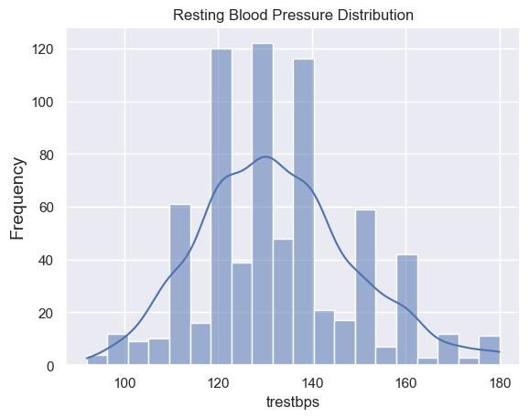
5. Dashboard
Heart Disease Risk and Patient Health Analysis
The dashboard is designed using Microsoft Power BI to provide an interactive overview of heart disease risk and patient health conditions. It combines KPIs, charts, slicers, and visual elements to analyze patient demographics, smoking status, family history, chest pain types, and heart disease diagnosis.

5.1. Dashboard Design Screenshot with Insights
Dashboard Design
The dashboard is designed with a clean and organized layout to present healthcare information clearly. It includes KPI cards at the top, interactive filters, and multiple charts for analyzing patient health data.
Main Dashboard Components:
Component | Description
KPI Cards | Display patient count and average age
Slicers | Filter data by age group, BMI category, and chest pain type
Bar Chart | Analyze heart disease prevalence by smoking status
Pie Chart | Show patient distribution by family history
Column Chart | Compare patient count by smoking status and sex
Donut Chart | Display heart disease diagnosis distribution
Pie Chart | Represent chest pain type distribution
Bar Chart | Compare average ST depression by smoking status
Dashboard Screenshot

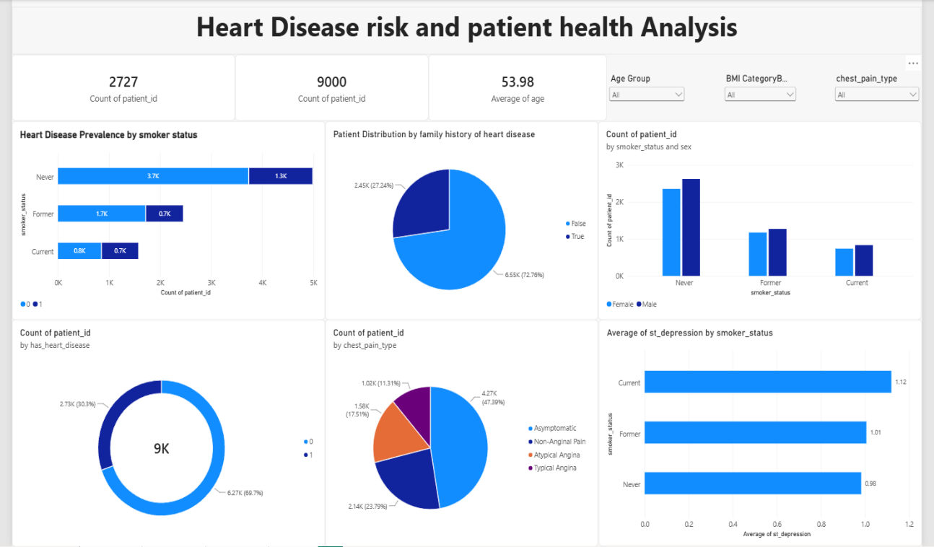
Figure 5.1: Heart Disease Risk and Patient Health Analysis Dashboard
5.2. Dashboard Insights
Insights :
Overall Prevalence: 30.3% of the 9,000-patient population (2,727 patients) has been diagnosed with heart disease, against an average patient age of 53.98 years.
Smoking & Prevalence: Never smokers make up the largest share of both diagnosed and non-diagnosed patients in raw counts, but Current and Former smokers show a visibly higher proportion of diagnosed cases relative to their group size.
Family History: 27.24% of patients report a family history of heart disease, a meaningful minority worth tracking alongside other risk indicators.
Chest Pain Presentation: Asymptomatic presentation dominates at 47.39%, ahead of Non- Anginal Pain (23.79%), Atypical Angina (17.51%), and Typical Angina (11.31%).
Stress Response Signal: Average ST-depression rises with smoking exposure — 0.98 (Never) → 1.01 (Former) → 1.12 (Current).
6. Report
6.1. Report1
Dashboard 1: Cardiovascular Health & Risk Insights
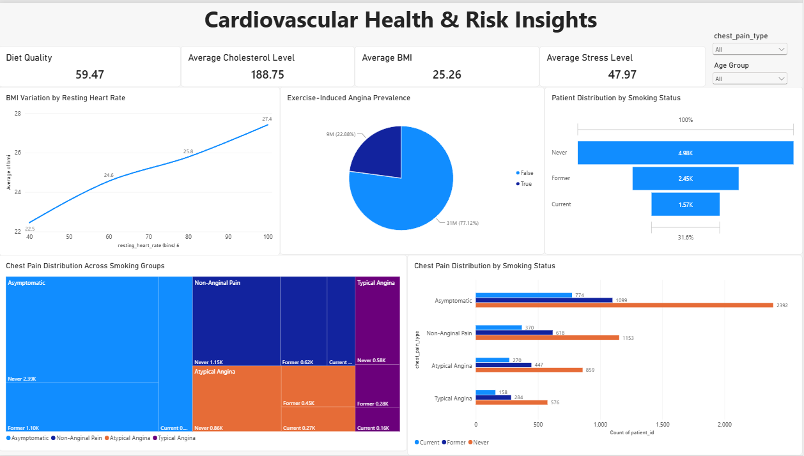
Insights :
- Average health profile: The average cholesterol is 188.75, BMI is 25.26, stress score is 47.97, and diet quality score is 59.47.
- Exercise-induced angina: 22.88% of patients show exercise-induced angina, while 77.12% do not.
- Smoking population: Never smokers form the largest group (4.98K), followed by Former smokers (2.45K) and Current smokers (1.57K).
- BMI & resting heart rate: Average BMI increases from 22.5 to 27.4 as resting heart rate rises, indicating a clear positive relationship.
- Chest pain pattern: Asymptomatic is the most common chest-pain category, followed by Non-Anginal Pain, Atypical Angina, and Typical Angina.
- Smoking & chest pain: Never smokers have the highest patient counts across all chest-pain types, while current smokers have the lowest.
- Risk indication: The combination of higher resting heart rate, increasing BMI, and exercise-induced angina highlights important cardiovascular risk patterns for further investigation.
6.2. Report2
Dashboard 2: Patient Wellness & Heart Health Analytics
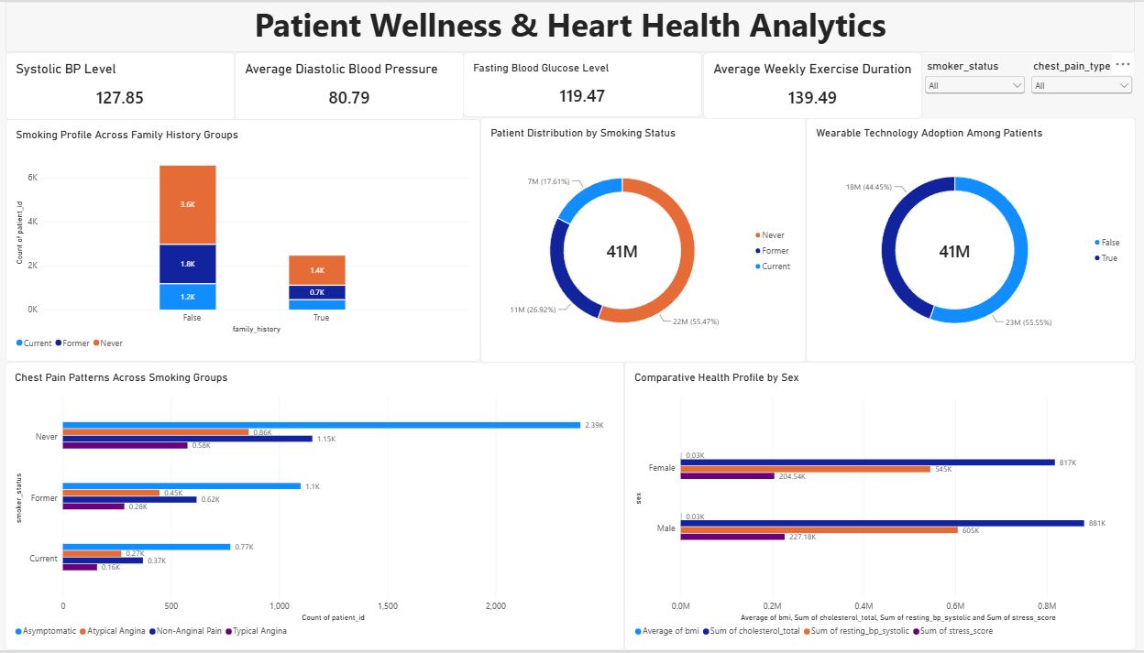
Insights :
- Blood Pressure & Glucose: Average systolic BP is 127.85, diastolic BP is 80.79, while average fasting blood glucose is 119.47.
- Exercise & Wellness: Patients report an average of 139.49 minutes of exercise per week, indicating a measurable level of weekly physical activity.
- Family History: Patients without a family history form the larger group, with approximately 6.5K patients, compared with 2.5K who have a family history.
- Smoking Profile: Never smokers represent the largest patient group (~4.98K), followed by former smokers (~2.45K) and current smokers (~1.57K).
- Wearable Adoption: Around 55.55% of the displayed patient measure is associated with wearable ownership, while 44.45% does not.
- Chest Pain Patterns: Asymptomatic cases are the most common across all smoking groups, while Typical Angina represents the smallest category.
- Smoking & Chest Pain: Never smokers have the highest number of patients across the chest-pain categories, largely because they are the largest smoking-status group.
- Gender Comparison: The comparative health profile shows noticeable differences between male and female patients across cholesterol, resting BP and stress-related measures.
- Overall Health Profile: The combination of blood pressure, glucose, exercise, smoking, family history and chest-pain patterns provides a broad view of the patients' cardiovascular risk and lifestyle profile.

7. Performance Testing
- Performance testing reviews the volume of data rendered from the database, the impact of data filters on responsiveness, and the visual/calculated complexity of the report. Optimizing these factors ensures
7.1 Utilization of Data Filters
Slicers and visual-level filters were applied throughout the dashboard to allow stakeholders to dynamically segment patients and focus on specific risk categories.
Page 1 Slicers: Age Group, BMI Category, chest_pain_type
Page 2 Slicers: chest_pain_type, Age Group
Page 3 Slicers: smoker_status, chest_pain_type
Performance Impact: Filtering at the data layer reduces the volume of records processed per visual, improving query response times across all report pages.
7.2 Calculated Columns and Measures
Two DAX calculated columns were created and implemented on the main data table (heartdisease heart_disease_risk_2026) to derive critical patient segmentation categories for heart disease risk analysis:
1. Age Group
Categorizes patients into primary age demographics to evaluate age-related risk trends.
Code snippet
Age Group =
SWITCH(
TRUE(),
'heartdisease heart_disease_risk_2026'[age] < 30, "Young Adult",
'heartdisease heart_disease_risk_2026'[age] < 46, "Adult",
'heartdisease heart_disease_risk_2026'[age] < 61, "Middle Age",
"Senior"
)
2. BMI Category
Segments patients according to standard Body Mass Index health classifications.
Code snippet
BMI Category =
SWITCH(
TRUE(),
'heartdisease heart_disease_risk_2026'[bmi] < 18.5, "Underweight",
'heartdisease heart_disease_risk_2026'[bmi] < 25, "Normal",
'heartdisease heart_disease_risk_2026'[bmi] < 30, "Overweight",
"Obese"
)
Performance Impact: While DAX calculated columns consume model RAM, evaluating row context during data refresh offloads runtime computation from DAX measures during visual rendering.
7.3 Visualizations Summary
A total of 27 visual elements (16 analytical charts and 11 KPI cards) were built across the three dashboard pages:
Key Performance Indicators (KPIs)
- 11 KPI Cards distributed across pages to surface high-level metrics (e.g., total patient counts, average metrics, risk rates).
Analytical Visuals (16 Charts)
- Heart Disease Prevalence by Smoker Status (Stacked Bar Chart)
- Patient Distribution by Family History (Pie Chart)
- Count of Patients by Smoker Status and Sex (Clustered Bar Chart)
- Count of Patients by Has Heart Disease (Donut Chart)
- Count of Patients by Chest Pain Type (Pie Chart)
- Average ST-Depression by Smoker Status (Bar Chart)
- BMI Variation by Resting Heart Rate (Line Chart)
- Exercise-Induced Angina Prevalence (Pie Chart)
- Patient Distribution by Smoking Status (Funnel Chart)
- Chest Pain Distribution Across Smoking Groups (Icicle Chart)
- Chest Pain Distribution by Smoking Status (Grouped Bar Chart)
- Smoking Profile Across Family History Groups (Stacked Bar Chart)
- Patient Distribution by Smoking Status (Donut Chart)
- Wearable Technology Adoption Among Patients (Donut Chart)
- Chest Pain Patterns Across Smoking Groups (Bar Chart)
- Comparative Health Profile by Sex (Bar Chart)
Performance Impact: Rendering an average of ~9 visual elements per page maintains optimal visual density while minimizing cross-filtering query load on the underlying engine.

8. Conclusion & Key Observations
8.1 Summary of Findings
The Heart Disease Risk Analysis Dashboard successfully provides interactive, multi-dimensional visibility into key patient demographics, lifestyle factors, and clinical indicators across three target pages.
Clinical & Demographic Insights: Risk segmentation through derived calculated columns (Age Group and BMI Category) highlights distinct risk spikes among older age groups and higher BMI tiers, particularly when combined with lifestyle indicators such as smoking status.
Slicer Integration: Cross-filtering via page-level slicers (chest_pain_type, Age Group, smoker_status, and BMI Category) allows clinical stakeholders to isolate specific patient cohorts dynamically without performance bottlenecks.
8.2 Dashboard Performance & Design Observations
Optimal Visual Density: Distributing the 27 elements (16 charts and 11 KPI cards) across 3 distinct pages keeps the per-page visual count below 10 elements. This prevents visual clutter while limiting the number of simultaneous DAX queries executed during cross-filtering.
Pre-calculated Data Modeling: Implementing Age Group and BMI Category as DAX calculated columns offloads computation to data refresh time rather than evaluation time, ensuring instantaneous dynamic rendering when users apply filters.
Standardized Risk Metrics: The combination of top-level KPI summary cards and granular analytical visualizations (e.g., Icicle charts, stacked/grouped bar charts) offers a balanced layout for both executive overviews and detailed clinical exploration.
8.3 Technical Recommendations for Future Optimization
1.Upstream Processing: Consider moving the logic for Age Group and BMI Category from DAX calculated columns upstream into Power Query (M) or the underlying SQL database view. This will optimize memory usage and reduce overall data model size.
2.Measure Offloading: As data volume expands, transition aggregations into dedicated DAX measures using CALCULATE() and SUMMARIZE() to maintain high query responsiveness under larger datasets.
3.Visual Streamlining: For high-density visual pages, evaluate consolidating pie and donut charts where clustered or stacked bar charts provide clearer ratio comparisons across overlapping demographic segments.
9. Future Scope
To further enhance the value, scalability, and predictive capability of the Heart Disease Risk Analysis Dashboard, the following advancements and enhancements are proposed for future iterations:

9.1 Advanced Analytics & Predictive Modeling
Machine Learning Integration: Integrate predictive ML models (e.g., Azure Machine Learning or R/Python scripts in Power BI) to output real-time Heart Disease Risk Scores based on multi-variate inputs (age, BMI, resting heart rate, ST-depression, and smoking habits).
Key Driver Analysis: Implement Power BI’s native Key Influencer and Decomposition Tree visuals to automatically highlight the primary indicators contributing to elevated heart disease prevalence across patient segments.
9.2 Data Source & Infrastructure Enhancements
Upstream Data Transformation: Transition calculated fields (Age Group and BMI Category) from DAX calculated columns to data warehouse SQL views or Power Query (ETL layer) to reduce memory consumption and speed up model refreshes.
Real-time / Incremental Data Refresh: Upgrade from scheduled batch refreshes to Incremental Refresh or DirectQuery mode with automatic page refreshes (APR) to support real-time patient monitoring and wearable tech integration.
9.3 Expanded Clinical & Behavioral Metrics
Longitudinal Risk Tracking: Incorporate historical patient data to track health progression, BMI shifts, and heart rate variability over time rather than relying solely on single-point snapshot data.
Deeper Wearable Device Insights: Expand analytics around wearable technology usage, incorporating continuous monitoring metrics such as average daily step count, sleep quality, and active heart rate zones.
9.4 User Experience & Accessibility Upgrades
Row-Level Security (RLS): Implement dynamic Row-Level Security based on user roles (e.g., Clinical Staff, Department Heads, Executive Leadership) to enforce data privacy and compliance standards (HIPAA/GDPR).
Mobile Layout Optimization: Design tailored layout templates for mobile devices and tablets, enabling on-the-go access for physicians and healthcare administrators.
10. Appendix
10.1 Source Code & DAX Definitions
Below are the primary Data Analysis Expressions (DAX) used to generate calculated fields and segmentations within the Power BI data model:
1. Age Group (Calculated Column)
Segments patient records into standardized age brackets for demographic analysis.
Code snippet
Age Group =
SWITCH(
TRUE(),
'heartdisease heart_disease_risk_2026'[age] < 30, "Young Adult",
'heartdisease heart_disease_risk_2026'[age] < 46, "Adult",
'heartdisease heart_disease_risk_2026'[age] < 61, "Middle Age",
"Senior"
)
2. BMI Category (Calculated Column)
Classifies Body Mass Index values into clinical categories to support health risk stratification.
Code snippet
BMI Category =
SWITCH(
TRUE(),
'heartdisease heart_disease_risk_2026'[bmi] < 18.5, "Underweight",
'heartdisease heart_disease_risk_2026'[bmi] < 25, "Normal",
'heartdisease heart_disease_risk_2026'[bmi] < 30, "Overweight",
"Obese"
)
10.2 Project Links & Repositories
GitHub Repository
https://github.com/poojithachereddy/Heart-disease-risk-patient-health-analysis.git

